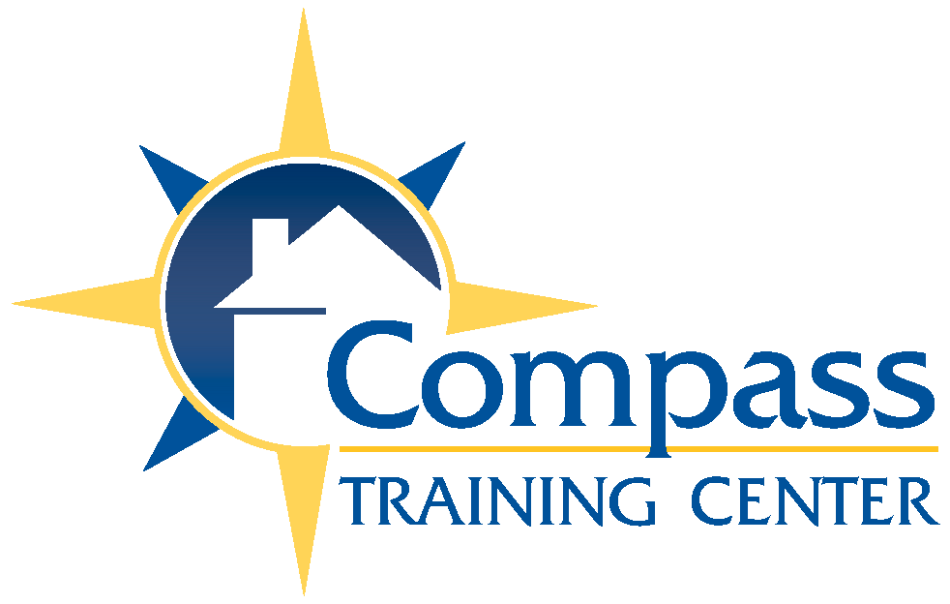
Compass Training Center
Speaking Agreement

We will need from your office:
- Your contact information (to include the following):
  - Contact number, email, & emergency phone number for day of event
 A contact name and/or address to send the invoice.
- Location where the seminar is to be held (with an address and contact phone number)
- Booklet (provided by us) for you to print the number needed for attendees
- Completed attendance roster (will provide blank copy that includes Name, Address, License type & number, phone & email for each attendee)
- A/V Requirements: Lavaliere Microphone, Flip Chart or White Board, Projector, table
Our office will provide:
- Andy’s years of knowledge from working in the real estate, mortgage, and safety
industries for the last 20+ years.
- Submission of attendees to the Florida DBPR for the CE credits
- Certificates of Completion – prepared & e-mailed to attendees
 Copy of state accreditation & copyright permission (upon request)
 An invoice that can be paid at the event or sent before the seminar.
 For Safety Classes Only: Our famous “Pop-Up Shop” of self-defense products!
Cost: $150/hour honorarium – only covers Andy speaking at the designated location
Additional Costs:
 Credit Hour Processing: included
 Mileage for outside of Central Florida area / Orange & Seminole Counties
  - At current IRS Mileage rates from our office to location and back
 If more than 2 hours drive, hotel may be requested.

Cancellation Policy (Prior to Event) NOTE: Any travel costs already incurred can’t be waived and will be invoiced.
31 days or more – no fee 4-30 days – ½ of speaking fee 0-3 days: full seminar fee

Class Title: ___________________________________________________Number of Hours:____

Event Date: __________________________ Event Time: _________________________

Event Location Address:_______________________________________________________________

____________________________________ Andy Tolbert ____ President _
Name Title Name Title

Signature ____________________________ Signature _____________________

Company: ____________________________ Compass Training Center LLC
EIN#02-0567187
Address: _____________________________ PO Box 952674
Lake Mary, FL 32795
City, State, Zip: ________________________ Mobile: 407-448-4994
Andy@AndyTolbert.com
P: ___________________________________

Email: __________________________

